Assignment 6: NAT and PAT Concepts
Topic: What is NAT/PAT? Importance in IP Address Conservation, Dynamic PAT Configuration
Shreya Panchal

Theory Overview

1. What is NAT (Network Address Translation)?
Network Address Translation (NAT) is a method used to remap one IP address space into another by modifying network address information in the IP header of packets while they are in transit across a traffic routing device. It allows local networks with private IP addresses (defined by RFC 1918) to communicate with public networks like the Internet.

2. What is PAT (Port Address Translation)?
Port Address Translation (PAT), also known as NAT Overload, is an extension of NAT that permits multiple devices on a local private network to map to a single public IP address simultaneously. It achieves this unique distinction by tracking traffic via distinct source port layers rather than just raw IP fields, drastically reducing the demand for public IPv4 spaces.

Tasks & Answers

Task 1: Static NAT Implementation in Cisco Packet Tracer
Question: In Cisco Packet Tracer, set up a simple network with a router, one internal PC, and one external PC. Assign private IP addresses to the internal PC and public IP addresses to the external PC, then configure static NAT on the router to allow the internal PC to communicate with the external PC.
Network Topology Layout:
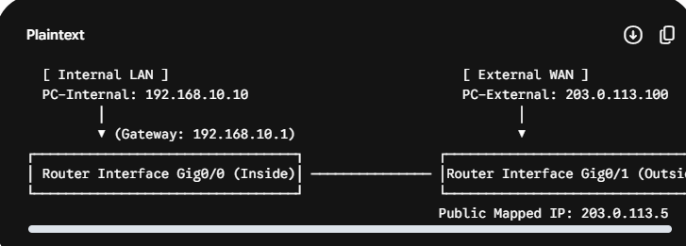
Configuration Steps:
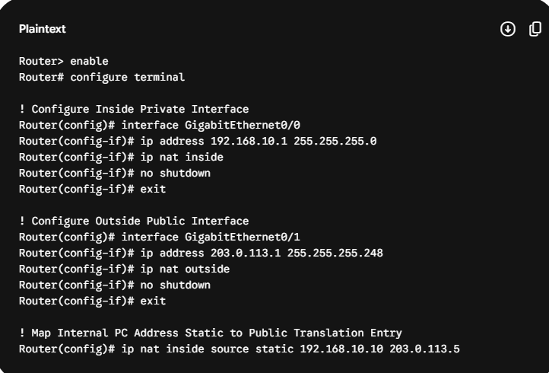

Task 2: Port Address Translation (PAT / NAT Overload) Setup
Question: Configure Port Address Translation (PAT) on a router in Packet Tracer so that two internal PCs with private IP can access a simulated public web server using a single public IP address. Use the IP Nat inside source list command with overload to enable PAT.
Configuration Steps:
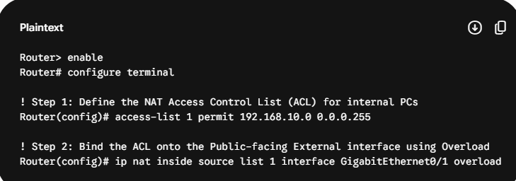
Note: This enables PAT, ensuring that traffic coming from any host in the 192.168.10.0/24 network uses unique source port numbers attached to the outside interface's public IP address.

Task 3: Verifying Traffic & Viewing Translation Tables
Question: Test your NAT configuration by sending a ping from the internal PC to the external PC and capture the NAT translation table on the router to verify the address mapping.
• Open the Command Prompt on PC-Internal and verify routing paths by issuing:
ping 203.0.113.100
• Access the console line of the Gateway Router and review active mapping sessions using:
show ip nat translations
Expected Table Verification Output:
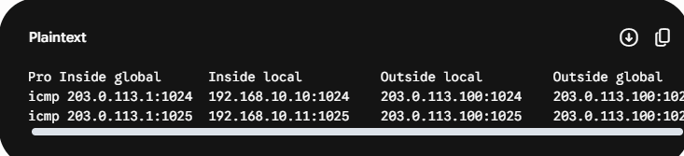
The output confirms that multiple inside local IP addresses are mapped to the same single public IP (203.0.113.1), separated uniquely by port strings (1024, 1025).

Task 4: Modifying Topology to Scale with Additional Internal Nodes
Question: Modify your Packet Tracer topology to add a third internal PC. Update your NAT or PAT configuration so all three internal PCs can access the external network, and verify that each translation appears in the router's NAT table.
Because our PAT setup uses a standard dynamic sub-net permission wildcard (192.168.10.0 0.0.0.255), any new host added within this segment is supported automatically without needing additional commands.
Verification Execution Steps:
• Connect a third machine (PC-Internal-3) to the local switch and assign it the IP 192.168.10.12.
• Generate continuous web or ping streams from all three machines out to the destination server.
• Execute show ip nat translations on the router console to see all three active translations:
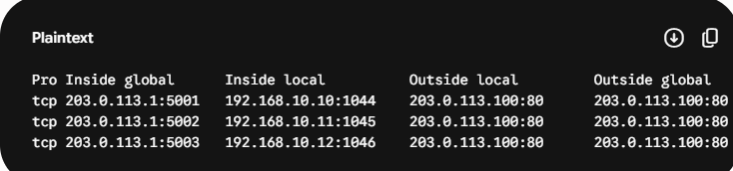

Task 5: Real-World Enterprise Scenarios & Failure Analysis
Question: Explain in your own words how NAT and PAT help apps like Zomato or Flipkart serve millions of users with limited public IP addresses. Give two real-world scenarios where incorrect NAT/PAT setup could break connectivity for users.

Platform Scaling via PAT:
Large platforms like Zomato or Flipkart host their core operations inside highly dense backend cloud zones with thousands of microservices, worker nodes, and databases communicating internally via private IPs. When millions of consumers use these platforms, PAT enables all outbound requests to route through shared, high-capacity enterprise internet gateways. By dynamically assigning unique source ports to each session, thousands of internal systems can connect to external services using only a few public IP addresses.

Failure Scenarios Due to Misconfiguration:
Scenario 1: NAT Port Exhaustion (Overload Capacity Reached)
What Happens: A single public IP address can support a maximum of around 65,000 concurrent port connections. If Flipkart launches a high-traffic flash sale and the gateway router is misconfigured to use only one public IP for thousands of internal database lookups and payment responses, the available source ports will run out completely.
The Result: New users attempting to checkout will face payment dropouts, connection timeouts, and incomplete page loads, breaking app connectivity during peak traffic hours.
Scenario 2: Strict Asymmetric Routing due to Missing Inside/Outside Statements
What Happens: If an administrator accidentally forgets to apply the ip nat inside statement to a new internal VLAN interface or misconfigures the Access Control List boundaries, traffic from that zone will route onto the internet with its original private IP address intact.
The Result: Because public routers drop private RFC 1918 addresses immediately, returning packets will fail to route back to the user, completely cutting off app connectivity for those users.

